Analysis Report
for
How Can a Team Become Better at Offensive Efficiency to Increase its Chances of Winning Games for NCAA Division I Basketball Programs?

Prepared by Armando Zapata

Creation: 03/12/19

Overview
The application of sports science to basketball settings, specifically the implementation of big data analytics techniques, has been growing recently, leading to an increased number of studies quantifying the players’ technical and tactical demands during games in an effort to shed some light on what is truly important to winning basketball games. There has been plenty of research done worldwide aimed at basketball game-related statistics attempting to provide insights that coaches could implement into his strategy in preparation for games. For example, previous studies investigating the differences between winning and losing teams in game-related statistics documented that defensive rebounds and assists were the most important indicators influencing winning in professional men’s Spanish basketball game play (Gomez, Lorenzo, Barakat, Ortega, and Palao, 2008) and in the Australian NBL (Scanlan, Teramoto, Delforce, and Dalbo, 2016). At the NBA level, a well-known book called “Basketball on Paper: Rules and Tools for Performance Analysis” was written by Dean Oliver, which attempts to use statistical analysis to distinguish what is truly important to winning basketball games and understand the underlying significance for each statistical measure. Most of the results that have been derived and are statistically-backed should provide coaches at different levels of basketball a strong framework, and they should use these results to optimize their training sessions and focus on the training of those variables that might increase the possibility to win games.

The NCAA Men’s Basketball is a different animal in and of itself. Although it is part of the same world of the sport of basketball, it should be treated slightly different compared to the NBA or other international basketball leagues given that it is regulated by a unique governing body and entails different rules. For example, games at the NCAA level compared to the NBA (National Basketball Association) have differences such as different shot clock duration, 30 seconds and 24 seconds respectively, as well as time allowed to advance the ball across the midcourt line, 10 seconds vs. 8 seconds, respectively (Favero, Conte, Tessitore, Gjullin, and MacKinnon, 2018). Additionally, NCAA basketball games are composed of two halves of 20-minute duration separated by a 15-minute break, while NBA games are composed of 4 quarters of 12-minute duration with a 15-minute break between the second and third quarter and a 2-minute break between the first and the last two quarters. These rule differences may lead to a different playing style, making the analysis of game-related statistics and tactical variables warranted in NCAA basketball games.

For purposes of this project, an initial attempt was made to create two models in an effort to predict the games for March Madness with a high degree of accuracy. Due to unforeseen events, a resubmission of the project will be delivered with a slight change. Instead of predicting the outcome of games for the NCAA Tournament, a prescriptive model will be created using the same data that was used for the first attempt, with the purpose of using and analyzing advanced statistics that would produce an output being indicative of a higher winning probability for NCAA Basketball games. Specifically, using advanced statistics on a per possession basis as opposed to the traditional box score per game statistics. This is an important distinction especially for NCAA Basketball because per game statistics ignore the pace at which many teams play. Conversely, per possession statistics has helped those who have been interested in sports analytics to put all teams on an even playing field, no matter what tempo the teams play at.

Implementing R as the programming language for the resubmission, 2 different analysis were performed: a classification tree and a support vector machine (SVM). Using the same advanced data for both analyses will provide a solid framework for the accuracy of both models, and it will be useful to compare the results and analyze the difference between them to provide more in-depth insight about the data.

Problem
How can a team become better at offensive efficiency in order to increase its chances of winning games for NCAA Division I Men’s Basketball Programs?

Result
Using a classification tree, a new column was generated that classified each team as best, average, and bad in terms of offensive efficiency based on the advanced statistics retrieved from the kenpom.com, taking into account the tempo used by each team for each year. The accuracy for this analysis yielded a 0.86408.

Using a support sector machine (SVM) analysis, the same data was used and in yielded a 0.9368071 accuracy.

Benefit
This project could be used as a framework for future predictive models that are being widely developed and used across the College Basketball programs across the board which could aid coaches in a more specific manner through the implementation of several advanced statistical measures.
Additionally, considering the hype around March Madness and how computing and machine learning advancements have led to the creation of many cutting-edge predictive algorithms, this project could serve as a stepping stone for those who are still trying successfully predict the Tournament’s outcome from beginning to the champion.

Statistical Tests

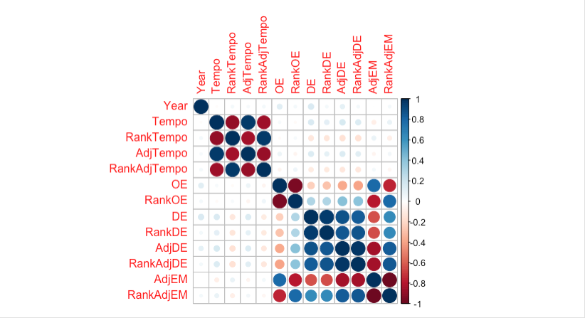

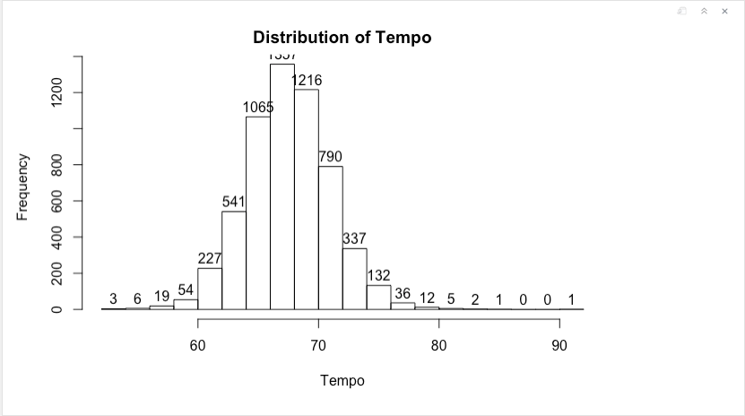

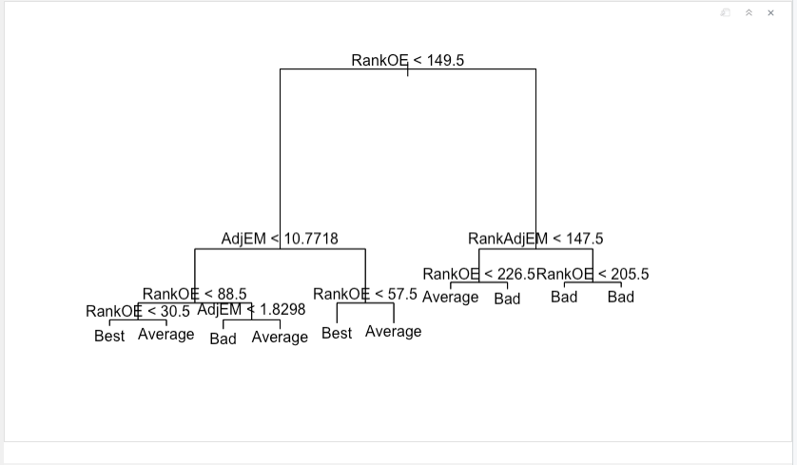

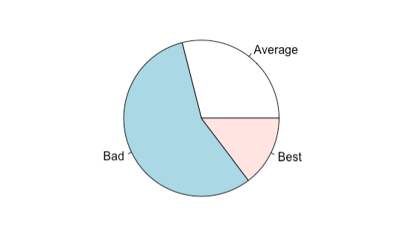

Conclusion
The motivation of this project came from being a huge basketball fan, mostly NBA, but considering that March Madness is just weeks away, it seemed right to at least broach the subject and establish a framework that could be used for further research in the future. Each March, more than an estimated 50 million Americans fill out a bracket for the National Collegiate Athletic Association (NCAA) men’s Division I basketball tournament (Barra 2014). The excitement around the annual three-week NCAA basketball tournament has become a phenomenon that galvanizes people from all over the country and worldwide. As exciting as the games can be, one doesn’t have to watch many, or even any to immerse yourself in the event. Millions of fans who are not into sports or basketball simply follow the action by keeping their eyes locked on their own picks in the brackets they filled out. To put it in context , even former President Barack Obama filled out one of ESPN’s brackets each year of his presidency, which was nationally televised.

As mentioned above, even if one’s school is not participating in the event, there are other ways to invest yourself into the event both emotionally and financially. The hype is so real surrounding this event, that even billionaire CEO of Berkshire Hathaway Warren Buffet offers on an annual basis that any employee who accurately predicts all Sweet 16 teams will receive $1 million in perpetuity. He even previously offered $1 billion for anyone who predicted a perfect bracket, which nobody has achieved in the 21-year history of ESPN’s bracket challenge. The odds of predicting a perfect bracket are anywhere from one in nine quintillion to about one in two billion.

Given the huge challenge this has become for many data scientists, even Kaggle, the website that organizes free analytics and modeling contests, hosted its first college basketball competition in the early months of 2014 (Lopez and Matthews, 2015). Referred to as the “Kaggle contest”, the competition drew more than 400 submissions. Michael Lopez and Gregory Matthews, participants of the event, employed the combination of modest statistical methods with informative data to meet or exceed the accuracy of more complex models when attempting to predicts the NCAA men’s basketball tournament. Other participants employed more complex models using additional data, such as each team’s travel distance, seed information, conference, and past tournament performances (Kaggle 2014). The point of this is that there are many avenues that people may take in attempting to achieve this seemingly impossible task, but the common denominator to win any pool comes from the combination of skill and luck.

This project serves as a solid stepping stone for developing more complex algorithms. The use of advanced statistics poses a significant advantage and provides a high-level of insight of the data used that could be beneficial for those who keep attempting to develop a model that predicts the whole tournament. It seems that the use of informative data with traditional statistical tools can still result in predictions whose accuracy rivals that of more complex models.

References
Barra, A. 2014. Is March Madness a Sporting Event – or a Gambling Event? http://www.theatlantic.com/entertainment/archive/2014/03/Is-march-madness-a-sporting-event-or-a-gambling-event/284545/ (accesses March 9, 2019).
Favero, Terence; Conte, Daniele; Tessitore, Antonio; Gjullin, Aaron; Mackinnon, Domink; and Lupo, Corrado. Investigating the game-related statistics and tactical profile in NCAA division I men’s basketball games. (2018). Biology Faculty Publications and Presentations. 53.
Gomez, MA, Lorenzo A, Barakat R, Ortega E, Pelao JM. Differences in game-related statistics of basketball performance by game location for men’s winning and losing teams. Percept Mot Skills. 2008, 106(1):43-50.
Kaggle. 2014. Competition Forum. URL https://www.kaggle.com/c/march-machine-learning-mania/forums (accessed March 9, 2019).
Michael J. Lopez, Gregory Matthews. Building an NCAA Men’s Basketball Predictive Model and Quantifying its Success. Journal of Quantitative Analysis in Sports, 2015, 11-1.
Scanlan TA, Teramoto M, Delforce M, Dalbo JV. Do better things come in smaller packages? Reducing game duration slows game pace and alters statistics associated with winning in basketball. Int J Perf Anal Sport. 2016; 16(1): 157-170.

